SQL

* SQL stands for Structured Query Language. It is used for storing and managing data in relational database management system (RDMS).
* It is a standard language for Relational Database System. It enables a user to create, read, update and delete relational databases and tables.
* All the RDBMS like MySQL, Informix, Oracle, MS Access and SQL Server use SQL as their standard database language.
* SQL allows users to query the database in a number of ways, using English-like statements.

Rules:

SQL follows the following rules:

* Structure query language is not case sensitive. Generally, keywords of SQL are written in uppercase.
* Statements of SQL are dependent on text lines. We can use a single SQL statement on one or multiple text line.
* Using the SQL statements, you can perform most of the actions in a database.
* SQL depends on tuple relational calculus and relational algebra.

SQL process:

* When an SQL command is executing for any RDBMS, then the system figure out the best way to carry out the request and the SQL engine determines that how to interpret the task.
* In the process, various components are included. These components can be optimization Engine, Query engine, Query dispatcher, classic, etc.
* All the non-SQL queries are handled by the classic query engine, but SQL query engine won't handle logical files.

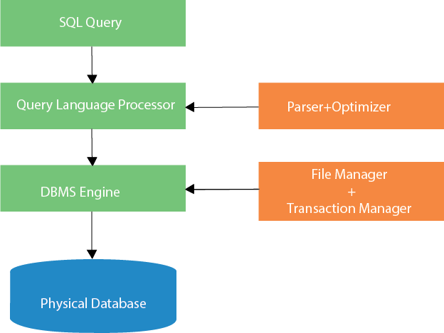

Characteristics of SQL

* SQL is easy to learn.
* SQL is used to access data from relational database management systems.
* SQL can execute queries against the database.
* SQL is used to describe the data.
* SQL is used to define the data in the database and manipulate it when needed.
* SQL is used to create and drop the database and table.
* SQL is used to create a view, stored procedure, function in a database.
* SQL allows users to set permissions on tables, procedures, and views.

# Advantages of SQL

There are the following advantages of SQL:

### High speed

Using the SQL queries, the user can quickly and efficiently retrieve a large amount of records from a database.

### No coding needed

In the standard SQL, it is very easy to manage the database system. It doesn't require a substantial amount of code to manage the database system.

### Well defined standards

Long established are used by the SQL databases that are being used by ISO and ANSI.

Skip Ad

### Portability

SQL can be used in laptop, PCs, server and even some mobile phones.

### Interactive language

SQL is a domain language used to communicate with the database. It is also used to receive answers to the complex questions in seconds.

### Multiple data view

Using the SQL language, the users can make different views of the database structure.

# SQL DatatypeSQL Commands

* SQL commands are instructions. It is used to communicate with the database. It is also used to perform specific tasks, functions, and queries of data.
* SQL can perform various tasks like create a table, add data to tables, drop the table, modify the table, set permission for users.

## **Types of SQL Commands**

There are five types of SQL commands: DDL, DML, DCL, TCL, and DQL.

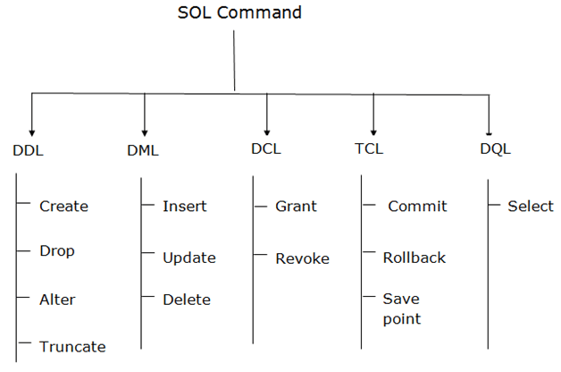

### 1. Data Definition Language (DDL)

* DDL changes the structure of the table like creating a table, deleting a table, altering a table, etc.
* All the command of DDL are auto-committed that means it permanently save all the changes in the database.

Here are some commands that come under DDL:

* CREATE
* ALTER
* DROP
* TRUNCATE

**a. CREATE** It is used to create a new table in the database.

**Syntax:**

1. CREATE TABLE TABLE_NAME (COLUMN_NAME DATATYPES[,....]);

**Example:**

1. CREATE TABLE EMPLOYEE(Name VARCHAR2(20), Email VARCHAR2(100), DOB DATE);

**b. DROP:** It is used to delete both the structure and record stored in the table.

**Syntax**

1. DROP TABLE table_name;

**Example**

1. DROP TABLE EMPLOYEE;

**c. ALTER:** It is used to alter the structure of the database. This change could be either to modify the characteristics of an existing attribute or probably to add a new attribute.

**Syntax:**

To add a new column in the table

1. ALTER TABLE table_name ADD column_name COLUMN-definition;

To modify existing column in the table:

1. ALTER TABLE table_name MODIFY(column_definitions....);

**EXAMPLE**

1. ALTER TABLE STU_DETAILS ADD(ADDRESS VARCHAR2(20));
2. ALTER TABLE STU_DETAILS MODIFY (NAME VARCHAR2(20));

**d. TRUNCATE:** It is used to delete all the rows from the table and free the space containing the table.

**Syntax:**

1. TRUNCATE TABLE table_name;

**Example:**

1. TRUNCATE TABLE EMPLOYEE;

### 2. Data Manipulation Language

* DML commands are used to modify the database. It is responsible for all form of changes in the database.
* The command of DML is not auto-committed that means it can't permanently save all the changes in the database. They can be rollback.

Here are some commands that come under DML:

* INSERT
* UPDATE
* DELETE

**a. INSERT:** The INSERT statement is a SQL query. It is used to insert data into the row of a table.

**Syntax:**

1. INSERT INTO TABLE_NAME
2. (col1, col2, col3,.... col N)
3. VALUES (value1, value2, value3, .... valueN);

Or

1. INSERT INTO TABLE_NAME
2. VALUES (value1, value2, value3, .... valueN);

**For example:**

1. INSERT INTO javatpoint (Author, Subject) VALUES ("Sonoo", "DBMS");

**b. UPDATE:** This command is used to update or modify the value of a column in the table.

**Syntax:**

1. UPDATE table_name SET [column_name1= value1,...column_nameN = valueN] [WHERE CONDITION]

**For example:**

1. UPDATE students
2. SET User_Name = 'Sonoo'
3. WHERE Student_Id = '3'

**c. DELETE:** It is used to remove one or more row from a table.

**Syntax:**

1. DELETE FROM table_name [WHERE condition];

**For example:**

1. DELETE FROM javatpoint
2. WHERE Author="Sonoo";

### 3. Data Control Language

DCL commands are used to grant and take back authority from any database user.

Here are some commands that come under DCL:

* Grant
* Revoke

**a. Grant:** It is used to give user access privileges to a database.

**Example**

1. GRANT SELECT, UPDATE ON MY_TABLE TO SOME_USER, ANOTHER_USER;

**b. Revoke:** It is used to take back permissions from the user.

**Example**

1. REVOKE SELECT, UPDATE ON MY_TABLE FROM USER1, USER2;

### 4. Transaction Control Language

TCL commands can only use with DML commands like INSERT, DELETE and UPDATE only.

These operations are automatically committed in the database that's why they cannot be used while creating tables or dropping them.

Here are some commands that come under TCL:

* COMMIT
* ROLLBACK
* SAVEPOINT

**a. Commit:** Commit command is used to save all the transactions to the database.

**Syntax:**

1. COMMIT;

**Example:**

1. DELETE FROM CUSTOMERS
2. WHERE AGE = 25;
3. COMMIT;

**b. Rollback:** Rollback command is used to undo transactions that have not already been saved to the database.

**Syntax:**

1. ROLLBACK;

**Example:**

1. DELETE FROM CUSTOMERS
2. WHERE AGE = 25;
3. ROLLBACK;

**c. SAVEPOINT:** It is used to roll the transaction back to a certain point without rolling back the entire transaction.

**Syntax:**

1. SAVEPOINT SAVEPOINT_NAME;

### 5. Data Query Language

DQL is used to fetch the data from the database.

It uses only one command:

* SELECT

**a. SELECT:** This is the same as the projection operation of relational algebra. It is used to select the attribute based on the condition described by WHERE clause.

**Syntax:**

1. SELECT expressions
2. FROM TABLES
3. WHERE conditions;

**For example:**

1. SELECT emp_name
2. FROM employee
3. WHERE age > 20;

* SQL Datatype is used to define the values that a column can contain.
* Every column is required to have a name and data type in the database table.

## **Datatype of SQL:**

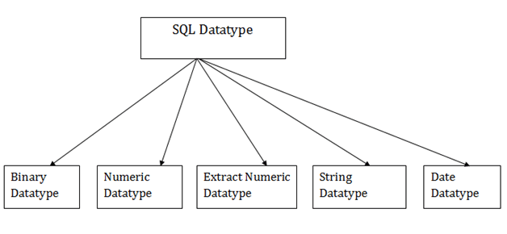

### 1. Binary Datatypes

There are Three types of binary Datatypes which are given below:

|  |  |
| --- | --- |
| **Data Type** | **Description** |
| binary | It has a maximum length of 8000 bytes. It contains fixed-length binary data. |
| varbinary | It has a maximum length of 8000 bytes. It contains variable-length binary data. |
| image | It has a maximum length of 2,147,483,647 bytes. It contains variable-length binary data. |

### 2. Approximate Numeric Datatype :

The subtypes are given below:

|  |  |  |  |
| --- | --- | --- | --- |
| **Data type** | **From** | **To** | **Description** |
| float | -1.79E + 308 | 1.79E + 308 | It is used to specify a floating-point value e.g. 6.2, 2.9 etc. |
| real | -3.40e + 38 | 3.40E + 38 | It specifies a single precision floating point number |

### 3. Exact Numeric Datatype

The subtypes are given below:

|  |  |
| --- | --- |
| **Data type** | **Description** |
| int | It is used to specify an integer value. |
| smallint | It is used to specify small integer value. |
| bit | It has the number of bits to store. |
| decimal | It specifies a numeric value that can have a decimal number. |
| numeric | It is used to specify a numeric value. |

### 4. Character String Datatype

The subtypes are given below:

Hello Java Program for Beginners

|  |  |
| --- | --- |
| **Data type** | **Description** |
| char | It has a maximum length of 8000 characters. It contains Fixed-length non-unicode characters. |
| varchar | It has a maximum length of 8000 characters. It contains variable-length non-unicode characters. |
| text | It has a maximum length of 2,147,483,647 characters. It contains variable-length non-unicode characters. |

### 5. Date and time Datatypes

The subtypes are given below:

|  |  |
| --- | --- |
| **Datatype** | **Description** |
| date | It is used to store the year, month, and days value. |
| time | It is used to store the hour, minute, and second values. |
| timestamp | It stores the year, month, day, hour, minute, and the second value. |